PEDRAS DA RAINHA BOWLS CLASSIC
15th- 22nd FEBRUARY 2022
BOWLING in the PORTUGUESE ALGARVE
“FIRST 64 ENTRIES ACCEPTED”
Prices from £105 per person includes bowls, prizes & accommodation (6 nights)
Flights are £58 return from Liverpool at present, so get booked in quick.
3 bowls events with £1800 cash played for based on full entry.
“play on the best grass Bowling green in Portugal”
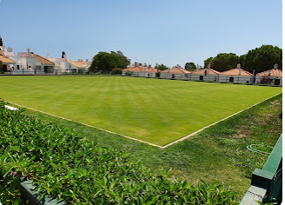
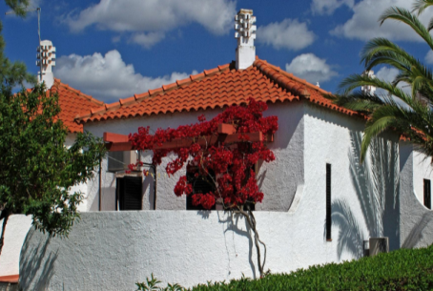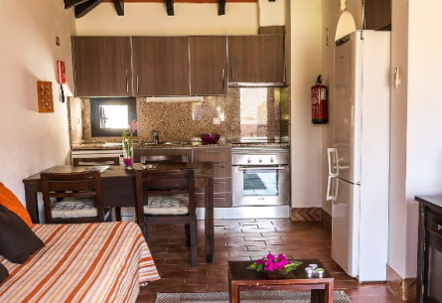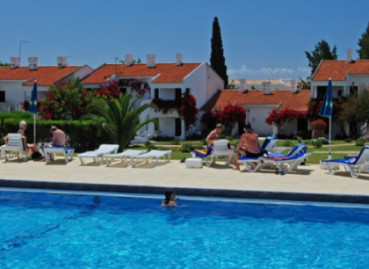
Play bowls in Algarve for 6 or 7 nights (add £20 to any room for night 7)
Rooms; 2, 3 or 4 share, single supp if needed. Two share £145 ea, 3 £132 ea.
Transfers can be booked for about £12 return.
Email to get in; nationalbowlsleague2021@virginmedia.com

